Eudey, Econ 302, January 2019
The Household Labor Supply Decision: Reference first half of Chapter 4
Reading
Things you can skip from this chapter:
For both editions 5 and 6
- An example: Consumption and Leisure are Perfect Complements

Partial vs General Equilibrium
Chapter 4 is micro, not macro, in the sense that the first half of Chapter 4 solves for the household’s labor supply decision taking wages as exogenous, and the second half of Chapter 4 solves the firm’s labor demand decision also taking wages as exogenous. It is not until Chapter 5 that we solve for the whole economy at once as we do in macro: equilibrium Consumption and GDP, equilibrium employment, and equilibrium real wages are all solved simultaneously in what we call a “general equilibrium” model of the economy. Solving for half the market at a time (just labor supply, for example, or just labor demand) is called “partial equilibrium”

Utility Maximization
The decision to work is a choice. You may have gotten used to economists thinking this way, but for many people outside the profession this statement is not very intuitive—it is more intuitive to think of work as a constraint (something they have to do) rather than something we choose to do. Casual observation though should convince you that not everyone of working age has a job, and not everyone who does have a job works the same number of hours, weeks, or years.
We’ve seen that a slower forecast for labor input implies a lower GDP forecast, which means the burden of government taxation will be spread across fewer people. If we can get more people to work, we can increase GDP and decrease that per-worker tax burden. Is that likely to happen? What does theory have to say about the labor force participation forecast?
The main assumption behind the Chapter 4 model of the consumer’s labor supply decision is that household’s try to make themselves as happy as possible, which means that they try to “maximize utility”. As usual in economics, there are tradeoffs in terms of the utility households get from increased work.
The tradeoff a household faces is that it gets utility (immediate happiness) from leisure time, but it also gets utility from consumer goods, which must be paid for by giving up leisure time in exchange for a (real) wage. The household imagines the different levels of total utility it would get from all the possible combinations of Consumption and leisure that are possible given that it is a price-taker in the labor market, it has to pay taxes, and given that there are a limited number of hours available in the day.
Utility maximization and an exact economic forecast
Formally, the household utility maximization problem can be represented in a math sentence:
* Maximize {Utility = f(Consumption, leisure hours)} = U(C,l)
Where
Consumption = wage*(16 hours available for work or leisure – l) – taxes
or
** C = w(h-l) - taxes

Substitution gives us Utility as a function of the leisure choice
*** Maximize U(w{h-l} – taxes, l)
`
At the maximum, the household cannot make any change in any direction and make itself better off, and it would never choose to make itself worse off. At the maximum, marginal changes in leisure have no impact on Utility (make the household neither better nor worse off). You can think of the household as being at the top of a “utility mountain”—a small step in any direction keeps on the top and a big step sends them down the mountain, which they would never want to do.
This idea of being at the top of the utility mountain can also be written as a math sentence: At the optimal level of leisure (l*)
U’(l*) = Marginal Utility of leisure = 0
- We can predict the optimal leisure choice if we know the utility function.
- We can predict the level of employment if we know the leisure choice
- We can predict the labor contribution to future GDP growth if we know U(l)
Sweet!
Of course, we don’t really know U(l) and we don’t really know if households are utility maximizers, which is a bit of a problem, but we can form models of household behavior, test those models using the Scientific Method, and use the best model we have to make the best forecast we can. We’ll do a bit of that this term.
We can also use graphs to give us a general idea of the direction of changes in economic variables—not a precise forecast but a heuristic one that can help us compare policy alternatives and predict how people will likely respond to changes in their economic environment. We’ll usually use graphical solutions to help us understand the economy rather than use math solutions to make precise predictions. We can cover a lot more topics that way as we won’t have to spend so much time learning math tools.

Utility Maximization and Graphs
Household utility is assumed to depend on only current Consumption and current leisure. That’s not at all realistic—there is no future period in the model so there is no saving or borrowing; there is no reason to invest today in future capital because there is no future, so there is no investment spending either and no capital stock. National Income accounting collapses to Y = C + G and the production function collapses to Y = f (labor productivity, labor). The point after all is to focus on the labor market and not get distracted by other stuff.
We’ll assume our Utility function has the following characteristics:
- More is preferred to less
  - There may be diminishing returns to both C and l, but more of things households like is better than less of the things they like
- Diversity has value
  - This means that households like a mix of C and leisure
- Consumption and leisure are both normal goods
  - This means that as incomes rise, households buy more things and also take more vacations, are able to enjoy years in retirement, etc

Because we’ll be using graphs to understand the model economy, each of those assumptions has a graphical implication:
- More is preferred to less.
  - Consider two combinations of {C, l} that each give the same utility, so that U(C1,l1) = U(C2, l2) and C1 ≠ C2 and l1≠l2.
    - It must then be the case that
      - C1>C2 and l1<l2 or
      - C1<C2 and l1>l2
  - This implies that that a line connecting two points with equal utility must be downward-sloping (C on the vertical axis, l on horizontal)

  - A graph of points of “indifference” (equal utility) must be downward sloping in a plot with C, l on the axes.

  - Indifference Curves (IC) are downward sloping

- Diversity has value
  - As we move down and to the right along an IC, households have less C and more leisure. Because households prefer diversity in C and leisure, they will only be indifferent about losing C if they are compensated with increasingly large increases in leisure (IC gets flatter as move to the right)
  - The slope of an “indifference curve” is convex (goes from steep to flat as you move from left to right along the IC)

- C and leisure are both normal goods
  - As incomes rise, households want more of both C and leisure, which cannot happen along a single Indifference Curve.
  - Higher incomes allow the household to be on a higher IC (shift in IC)

The Marginal Rate of Substitution
Slope is defined as rise over run. The slope of the indifference curve as households substitute out of Consumption into leisure is
$\frac{ΔC}{Δl}$ = $\left\{- \frac{MU\left(l\right)}{MU\left(C\right)} \right\}$ = - MRS(l,C) < 0
The household has less utility from one (either less leisure or less C along the IC) and so the slope is negative.
Because diversity has value, we know that the slope gets flatter as we move along the curve, so the MRS changes (marginal utility changes, reflecting diminishing returns)
Marginal Rate of Substitution is defined in positive terms, so the slope of the indifference curve is the negative of the MRS out of Consumption into leisure
- IC slope = - MRS(l,C)
Note that although slope is rise over run, so we have change in “C” in the numerator for slope formula $\frac{ΔC}{Δl}$, it is the marginal utility of leisure that is in the numerator for the MRS formula. The intuition behind that is that we measure the marginal utility of leisure in terms of the number of consumption goods we are willing to give up to get an additional unit of leisure

Constrained optimization: The household budget constraint
The assumption of the representative consumer model we are using in Chapters 4-5 is that all households in the economy have the same utility functions, but that households are constrained over time by different (or changing) budget constraints. A person with a very high wage has a better set of options than does a person with a low wage, but under the same circumstances they would each behave in the same way.
The budget constraint depends on labor income, on any profits, dividends, or inheritance that we’ll call “π” earned in the single period of the model, and tax payments:
C = w(h-l) – taxes + π
If there are lump sum taxes
Or
C = w(h-l)(1-t) + π
If there are payroll or proportional income taxes

Graphically the vertical intercept is at maximum C, where l=0
C(max) = wh – taxes + π
or if there are payroll taxes
C(max) = w(1-t)h + + π

Graphically the slope is how C varies with changes in leisure or
$\frac{ΔC}{Δl}$ = - w
Or, if there are payroll taxes
$\frac{ΔC}{Δl}$ = - w(1-t)

Graphically the horizontal intercept is where C=0
0 = w(h-l) + π– taxes
wl = wh + π – taxes
dividing by w we have
l(max) = h + (1/w)( π – taxes)
The horizontal intercept is a bit messy, so we’ll look at it more carefully for a minute:
l(max) = h + (1/w)( π – taxes)
Unlike C(max), there is an upper limit on how much leisure time a person can take because there is a limit on the number of hours available in a day. If the second term is non-positive, then l is never tempted to rise about h—so if π ≤ taxes then l(max) ≤ h as shown in Figure 4.3 in the textbook:

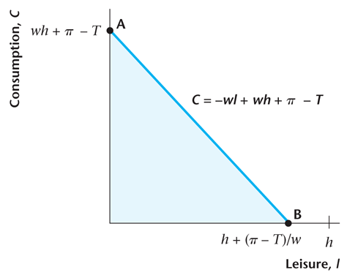
If however π ≥ taxes then households could buy consumer goods without ever having to work, and so the budget constraint has a vertical section (consumption possible at leisure = all the hours in the day) and then it has the usual slope after that, as shown in Figure 4.4 from the textbook:
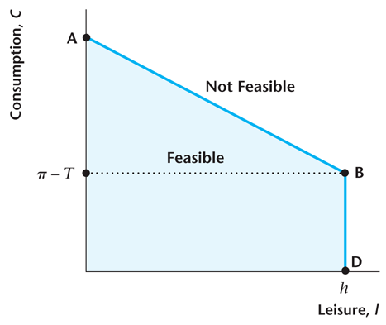
The difference in the graphs isn’t actually important—because households prefer diversity they will never choose l(max), but it does make chapter 4 a bit messy as there are two possible ways to graph the budget constraint. It is an annoyance but nothing more than that.
Finding Equilibrium
Households are assumed to choose the highest utility they can get, given their budget constraint. That means they are on the highest IC they can be on, given the size of h, w, and taxes. Graphically that happens where the IC is just tangent to the budget constraint. Any other IC is either outside the budget constraint (not feasible) or crosses the budget constraint (and therefore has utility equal to utility inside the budget constraint, which can’t be a maximum)
Shifts in the budget constraint that don’t also change the slope are pretty simple: If the budget constraint shifts, that is a change in income (rise in π or fall in lump-sum taxes) and
- because C and leisure are both normal goods, we know both C and leisure will rise (make sure to draw it that way!) as income rises
- because C and leisure are both normal goods, we know both C and leisure will fall (make sure to draw it that way!) as income falls

Shifts in the budget constraint that also change the slope are more complicated:
If the budget constraint shifts out and gets steeper (increase in w or fall in proportional income taxes), then
- because C and leisure are both normal goods, we know both C and leisure will rise (make sure to draw it that way!) as income rises
- because the return from labor rises, the opportunity cost of leisure rises and leisure falls (labor rises) while C again rises from higher returns from that increased labor input
- both the income effect and substitution effect cause C to rise as returns from labor rise
- the income effect causes leisure to rise, but the substitution effect cauess leisure to fall (change in leisure is ambiguous) as returns from labor rise.
And of course if returns from labor fall then everything moves in exactly the opposite direction.
In theory, then, the effect of rising wages or falling payroll taxes has an ambiguous effect on labor supply—-
- cutting taxes removes distortions in labor markets, but it isn’t obvious from the theory if removing those payroll taxes will cause labor to rise, fall, or stay the same.
- The Wells Fargo forecast said there is upside risk in the economic forecast because rising wages might encourage more people to enter the labor force, but that only happens if substitution effects dominate income effects—it could in theory just as easily go the other way (labor input could fall at higher returns from labor)

The Scientific Method should help us resolve this ambiguity—in other words we should be able to see form the data what the “stylized facts” are in terms of income and substitution effects. Unfortunately, it turns out that it is very hard to find a consistent predictable relationship between returns from labor and labor supply. That is the focus of the “Macroeconomics in Action: How Elastic is Labor Supply?” textbox in Chapter 4 and of the main application seen in class looking at that very important question.

